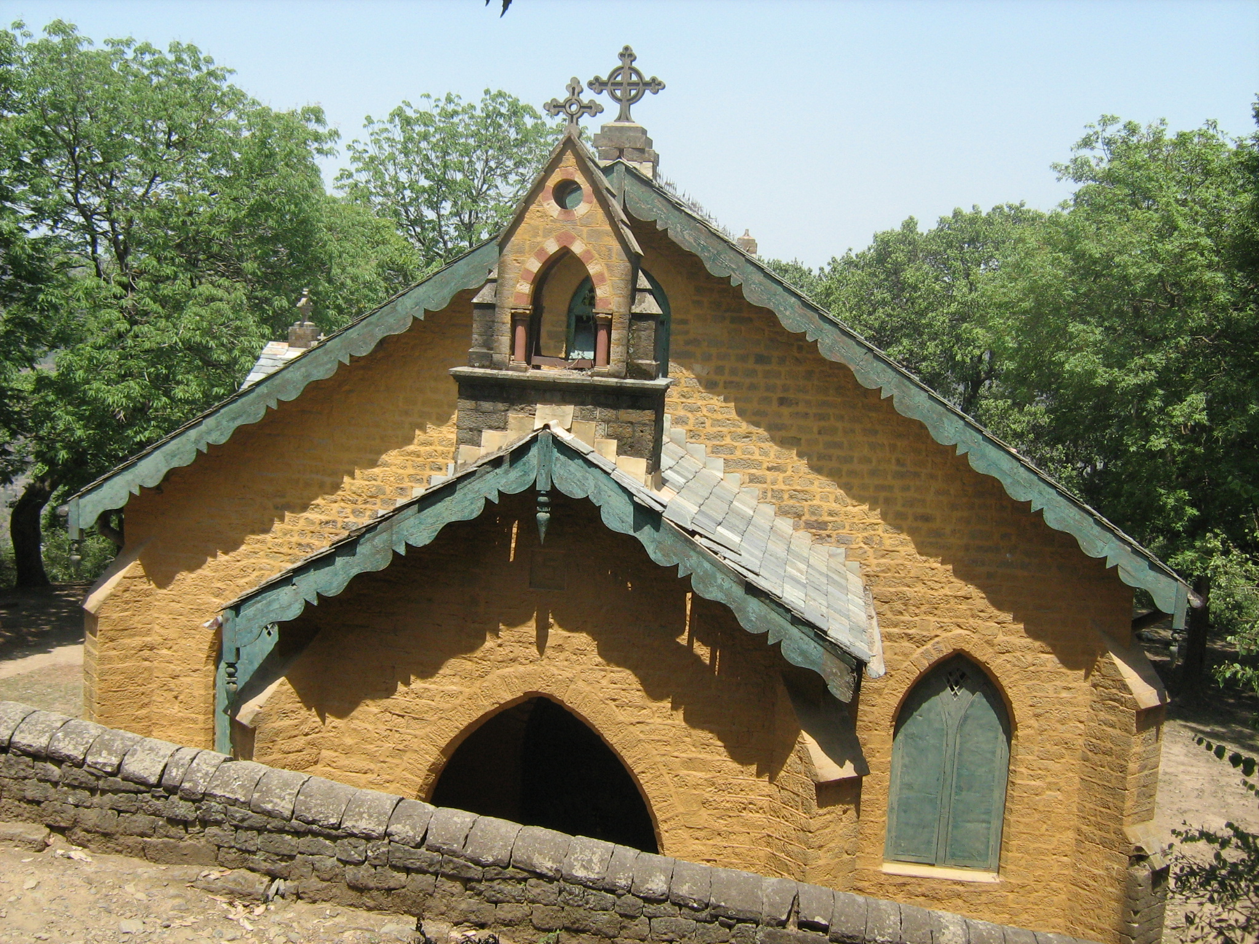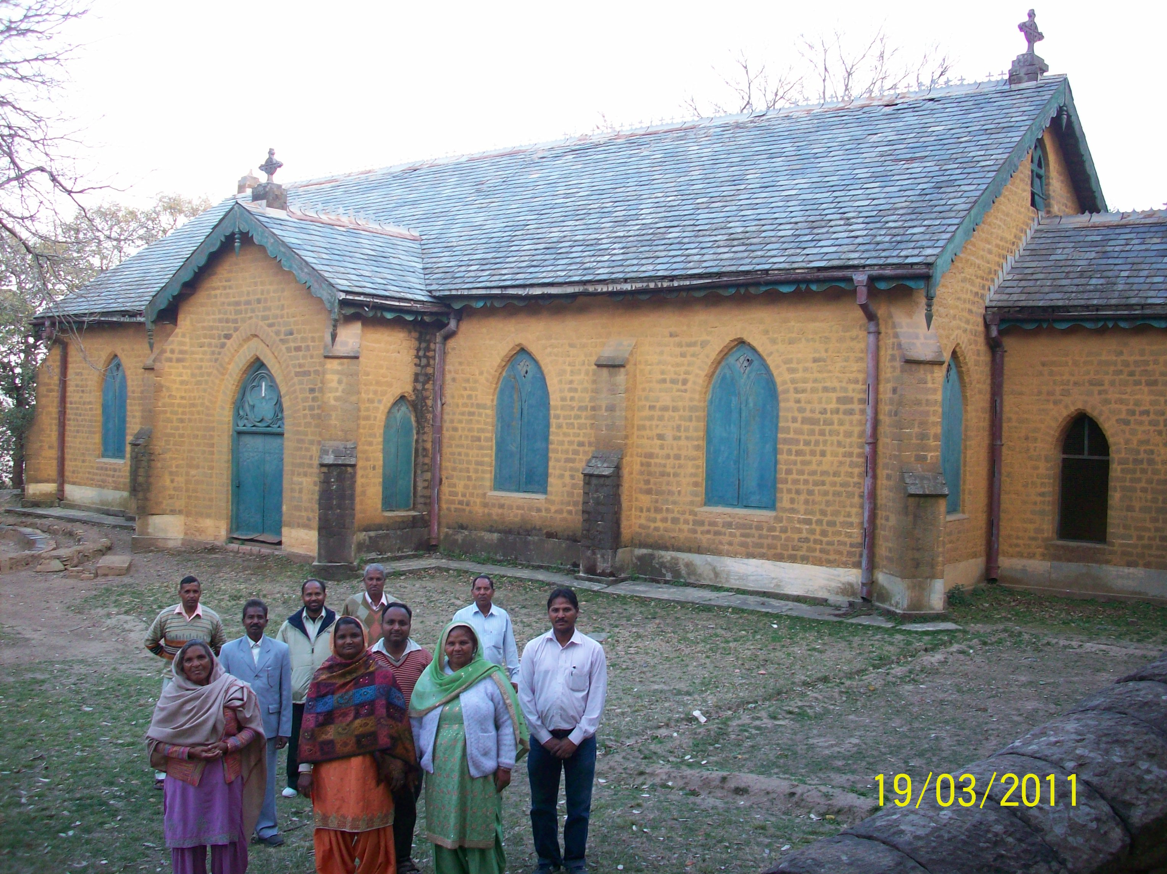
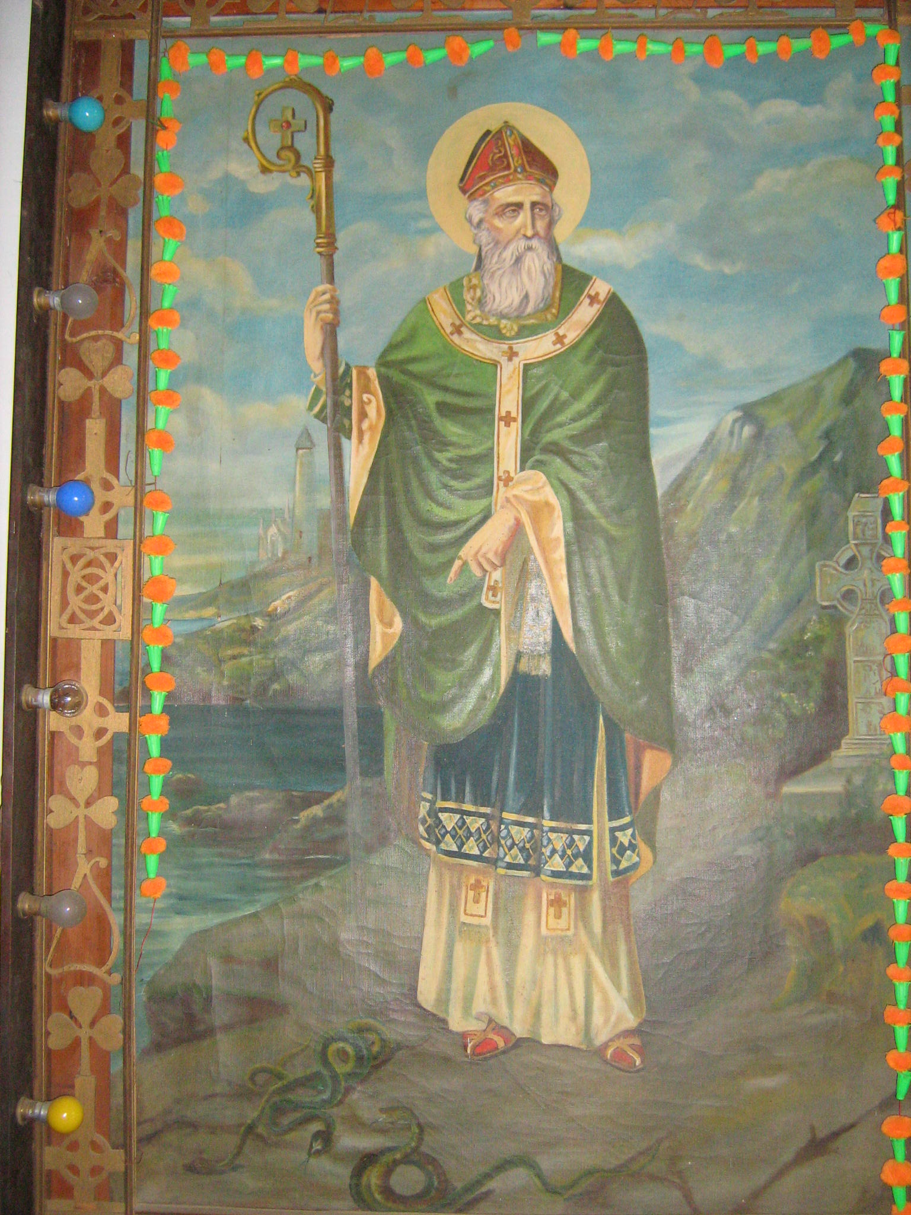
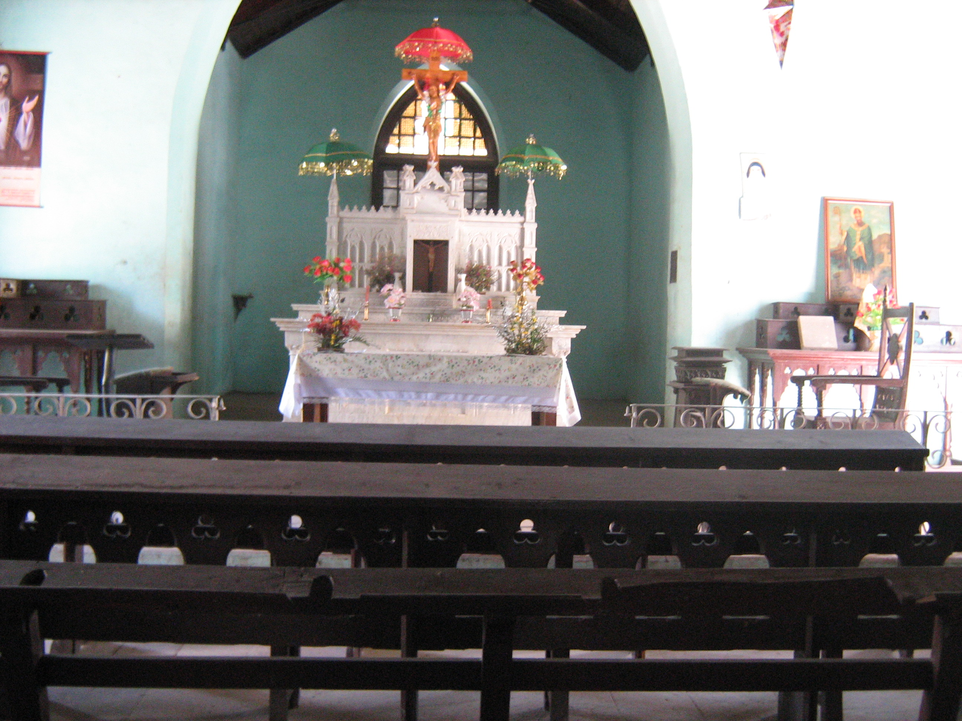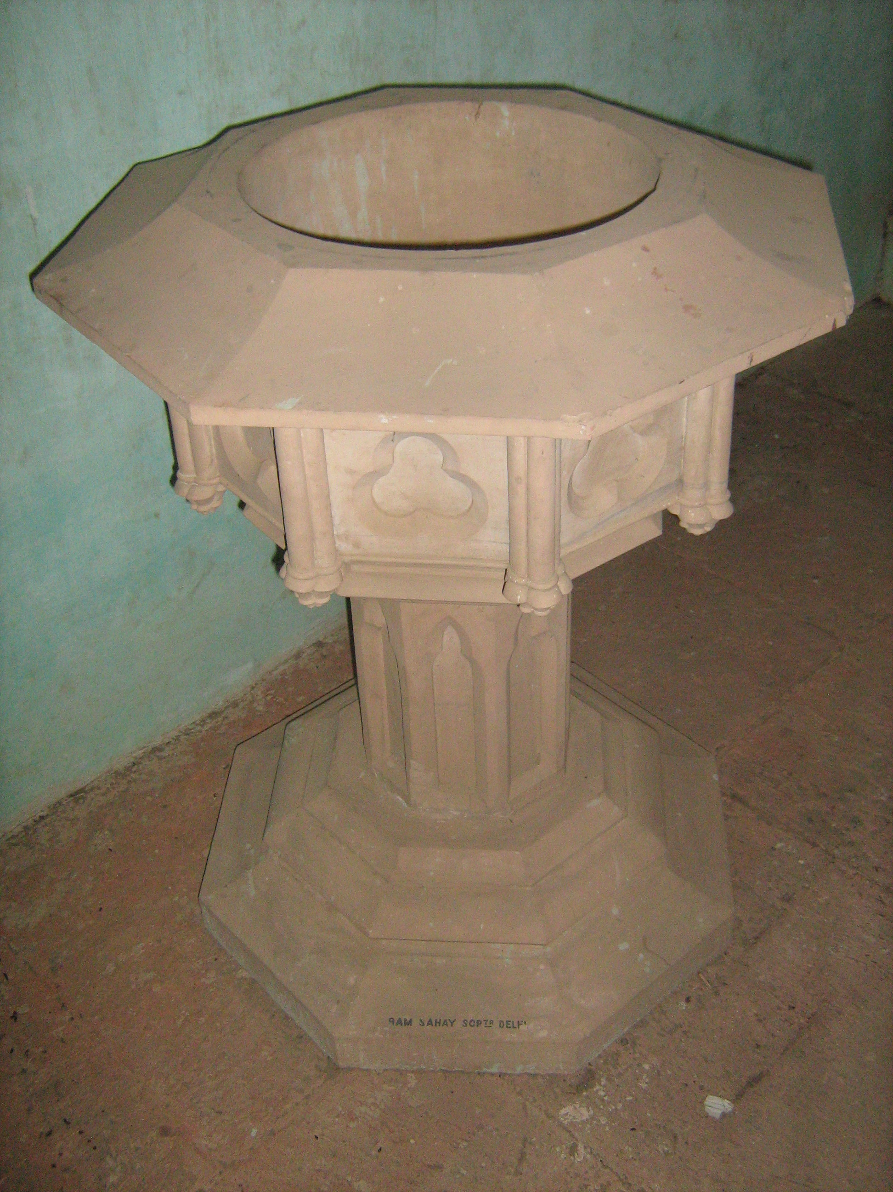
This is one of the oldest churches in North India and the first church to be built in Dagshai Cantonment. It’s plan was passed in12/8/1835 and immediately the construction began and final completion was in the year of 1852 at the cost of Rs.5030/- i.e. by contributions from the H.E.I.C Rs.2000/-., H.M.98th Reg.Rs.1600/-, Labour Cratis by 98th.Rs.500/-, H.M.87th R.I.E. Rs.470/-, H.M. 70th Reg.Rs.300/-, T.C. Carli D.D. the Bishop of Ajmira (Bishop and Vicar Apostolate of Hidustan) Rs.100/- and sum of the Rs.2000 received by him from the government of India through Chief Secretary to the govt. of India Mr.C.Allen Eoquere in 28th March 1853. Then the church was repaired in 1861 by Rev.Fr.Augustin. Formerly it was maintained by the Dagshai Garrison and was run by the Franciscan missionaries of the English province who were mainly serving the Irish soldiers posted at Dagshai and Kasauli. At present this ancient and miraculous church is managed by the priest Fr.Titus Babu who belongs to the Catholic diocese of Shimla-Chandigarh. The church is located in the cantonment area close to Cheri Cross, and just right side below the road leading from Military Section Hospital family ward to Unit Head quarter. It is located at the height of about 6000 Ft.
The church still maintains its grandeur. It is famous for its unique wooden interiors, the red stone floor, the unique Italian marble altar erected by George O.Weston in loving memory of his beloved wife Mary Rebecca Weston who died on 10th Dec.1909, and a Baptismal Pond made of Redstone. The slate roof and the Gothic structure are remarkable. The sylvan and serene atmosphere at the church is ideal for prayer and meditation. Down below the Church is the very old and beautiful Graveyard which reminds of the dedications of the soldiers as well as the faith of the people, and the love of both dead and the alive, also the sculptural beauty really attracts everyone.
The Church gets its name from the Irish saint St.Patrick, who lived around 350 A.D. to 450 A.D.in Ireland and by whose zealous missionary activities and devoted life in Jesus helped the people of Ireland to receive the grace of Jesus and became human from barbarians. He is known as the Patron saint of the Ireland. There is an accepted legend over him that he drew away all the poisoness snakes from there, therefore no snakes are found even atoday.
The faithful gather at the church on every Sunday and on other holy occasions for the Liturgical services. Christmas, Easter etc are celebrated in great earnest and vigor. The Holy service is held every Sunday. People do visit the church for blessings and healings through St.Patrick. For further information contact Fr.Titus Babu frtitusbabu@gmail.com, frtitusbabu@yahoo.com, 08988118641, and 09418436088.

Dagshai R.C. Cemetery No.4: This Garrison Cemetery No.4 in the cantonment of Dagshai is, of Colonial era was built in 1850 by Irish soldiers. This is filled with graves of officials and soldiers who lost their lives in wars or succumbed to ailments, besides number of graves showing the history, love, faith and memorials of the dear ones both living and the dead. Some of the beautiful graves are still intact and some are damaged. The available oldest tomb stone is dated of English Henry Charles H.M.22nd Reg. Aged 20,on 2nd June 1850 placed by his companions and the 2nd oldest is dated on Jun.1851 of Margaretta Seera the bellowed wife of Dhjab Page. Most of the tablets read “Requiescat in Pace” meaning, ‘Rest in Peace’. The graves and the tomb stones in it had been repaired and maintained by 93 Highlanders in 1893, 2ND Bn. of the Bihar reg. Easter 1968 and all ranks 2 Bihar in Jan. 2004. The records of graves and the cemetery is being maintained by the Catholic Church, and for further information you may kindly contact frtitusbabu@gmail.com, frtitusbabu@yahoo.com, 08988118641, and 09418436088.


